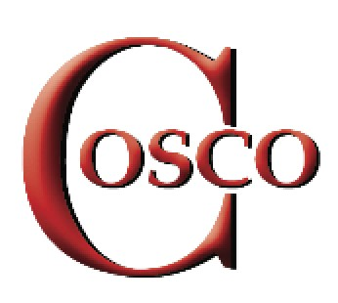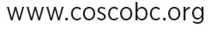

Affiliate Membership form 2022

_____New Membership _______Renewal

ORGANIZATION NAME: _______________________________________________________

NUMBER OF MEMBERS REPRESENTED_______________________

PRESIDENT: ____________________________________________

EMAIL: _______________________________________________

PHONE:______________________

ADDRESS: _______________________________________________________

TREASURER: ____________________________________________

EMAIL: _________________________________________________

PHONE: _______________________

ADDRESS: ______________________________________________

CONTACT PERSON: ______________________________________

EMAIL:_______________________________________________

PHONE:_______________________________________

ADDRESS: ____________________________________________

DELEGATES: name/phone number and email

_______________________________________________________

_______________________________________________________

_______________________________________________________

_______________________________________________________

_______________________________________________________

Please complete this form and send to: Membership Secretary, Council of Senior Citizens’ Organizations of BC (COSCO), Box 81131, South Burnaby, Burnaby, V5H 4E8. Phone: 604 444 4300
Membership fee: $_____ Donation $________

Disclaimer: COSCO collects the least amount of personally identifiable information possible so that we can maintain contact with our affiliates and/or members. COSCO does not share personally identifiable information with third parties for their use unless required by law to do so.

COSCO MEMBERSHIP

Delegate Meeting PLEASE UPDATE FORM WHEN REQUIRED

It is recognized that due to geographical constraints not all affiliates will be able to send delegates to the monthly delegate meetings.

However, when numbers of such affiliates shall be in the Lower Mainland area and able and willing to attend such meetings, they will be entitled to full delegate privileges for such meetings.

Meetings are normally held at the Hastings Community Centre, 3096 East Hastings Street, Vancouver (Hastings at Lillooet), on the second Friday of each month at 10 AM (except July and August). Delegates will be notified of any change of date, time and location.

Delegates

Affiliates are entitled to send delegates to COSCO Council meetings in accordance with the size of their membership as follows:

Up to 250 Members 1 Delegate
251 to 500 Members 2 Delegates
501 to 1,000 Members 3 Delegates
1,001 to 2,000 Members 4 Delegates
Over 2,000 Members 5 Delegates

Each delegate will be provided with a copy of the Constitution and Bylaws and the Polices and Procedures of the Council of Senior Citizens’ Organization of British Columbia (COSCO).

Membership Dues

Membership dues are payable as of the 2nd of January each year. Organizations joining the Council after October 1st in any year will have their dues waived for the balance of that year and membership would take effect in January of the following year.
Affiliation Fee, effective January 1:

MEMBERSHIP ANNUAL FEE
# of members
< 50 $ 25.00
51-100 50.00
  - 70.00
  - 100.00
  - 140.00
501-1,000 200.00
1,001-2,500 300.00
2,501-5,000 400.00
5,000 and over 500.00

